Input |  |  |  |  |  |  |  |  | Forward A (Rs) |  | Forward B (Rt)
EX/MEM.WR = ID/EX.Rs | EX/MEM.WR = ID/EX.Rt | MEM/WB.WR = ID/EX.Rs | MEM/WB.WR = ID/EX.Rt | ID/EX.RegDst (0 – I, 1 – R) )(Doesn’t matter) | EX/MEM.regWrite | MEM/WB.regWrite | EX/MEM.WR = 0  (Doesn’t matter) | MEM/WB.WR = 0  (Doesn’t matter) | Bit1 | Bit0 | Bit1 | Bit0
1 |  |  |  |  | 1 |  | 0 |  | 1 | 0
 | 1 |  |  | 1 | 1 |  | 0 |  |  |  | 1 | 0
0 |  | 1 |  |  | x | 1 |  | 0 | 0 | 1
x |  | 1 |  |  | 0 | 1 |  | 0 | 0 | 1
 | 0 |  | 1 | 1 | x | 1 |  | 0 |  |  | 0 | 1
 | x |  | 1 | 1 | 0 | 1 |  | 0 |  |  | 0 | 1
0 |  | 0 |  |  | x | x |  |  | 0 | 0
0 |  | x |  |  | x | 0 |  |  | 0 | 0
x |  | 0 |  |  | 0 | x |  |  | 0 | 0
x |  | x |  |  | 0 | 0 |  |  | 0 | 0
 | 0 |  | 0 | 1 | x | x |  |  |  |  | 0 | 0
 | 0 |  | X | 1 | x | 0 |  |  |  |  | 0 | 0
 | x |  | 0 | 1 | 0 | x |  |  |  |  | 0 | 0
 | x |  | X | 1 | 0 | 0 |  |  |  |  | 0 | 0
If regDst = 1 check match with both Rs and Rt, else check match with only Rs

Forwarding needed for Rs
When (exe/mem = 1 and ex/mem.regwrite = 1) or (mem/wb = 1 and mem.regwrite = 1) = true
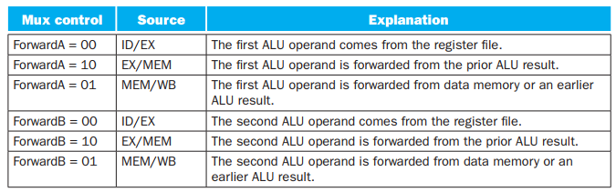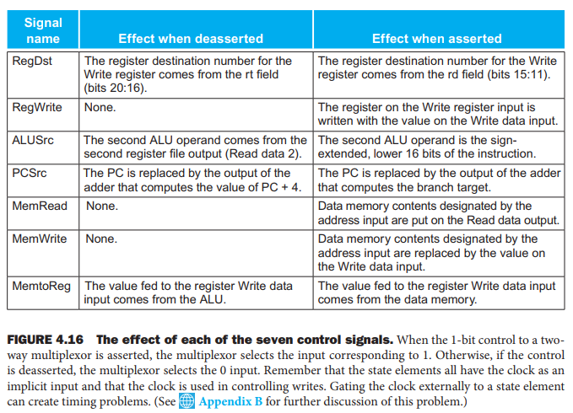

Load Use Hazard
Input |  |  |  |  | Hazard Detected
ID/EX.memRead | ID/EX.Rt = Rs | ID/EX.Rt = Rt | RegDst (0 – I, 1 – R | ID/EX.Rt = 0
1 | 1 | x | 0 | 0 | 1
1 | 1 | x | 1 | 0 | 1
1 | X | 1 | 1 | 0 | 1

Load-Store Forwarding
MEM/WB.memRead | EX/MEM.MemWrite | EX/MEM.Rt = MEM/WB.WR | MEM/WB.WR=0 | forward
1 | 1 | 1 | 0 | 1

Stall in branching
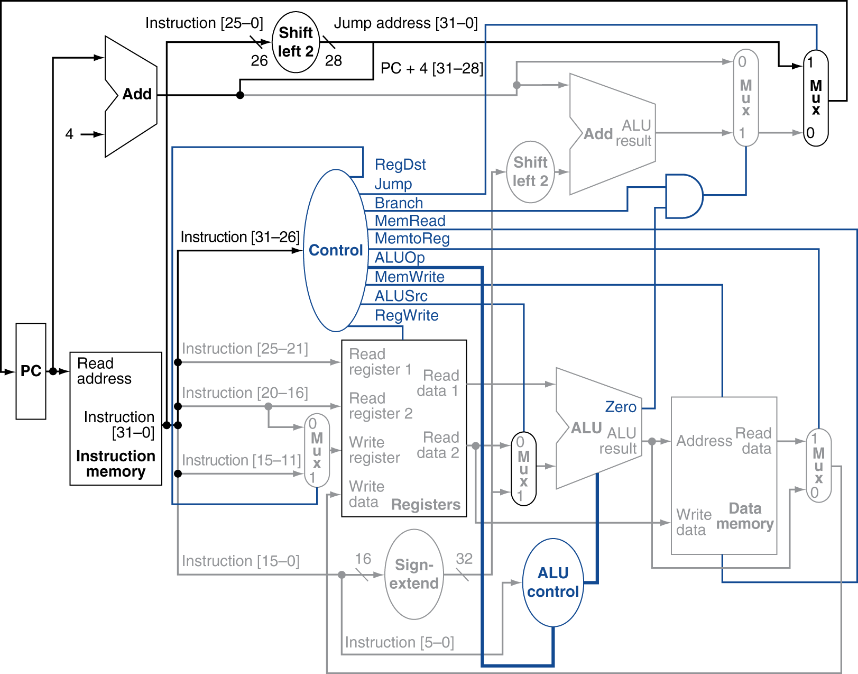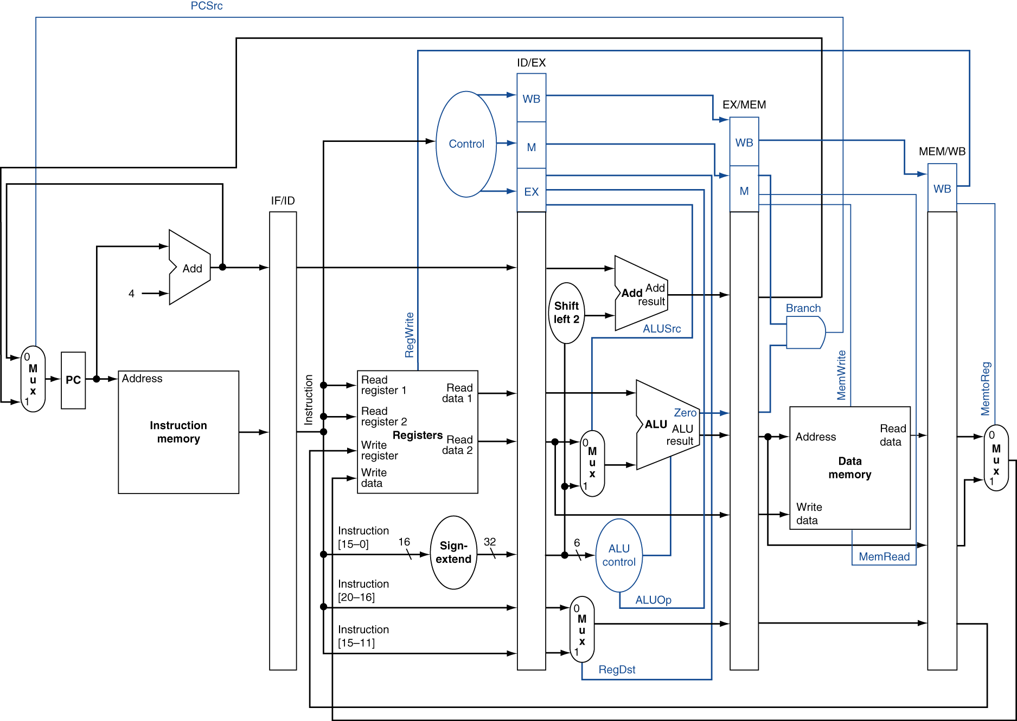

For sll(shirt left logical) and srl(shift right logical), A of ALU is shift amount and B of ALU is Rs, but for all other instruction, A of ALU is Rs

Read After After After Write Forwarding
Input |  |  | Output
MEM/WB.WR = IF/ID.Rs | MEM/WB.WR = IF/ID.Rt | MEM/WB.RW | ForwardA | ForwardB
1 |  | 1 | 1
 | 1 | 1 |  | 1

